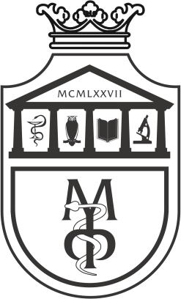

MORPHOLOGY2
HUMAN GENETICS

FIRST YEAR

2025/2026.

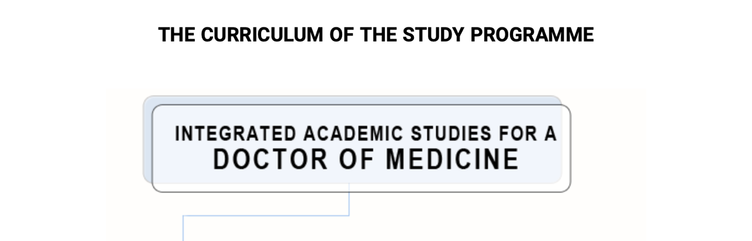
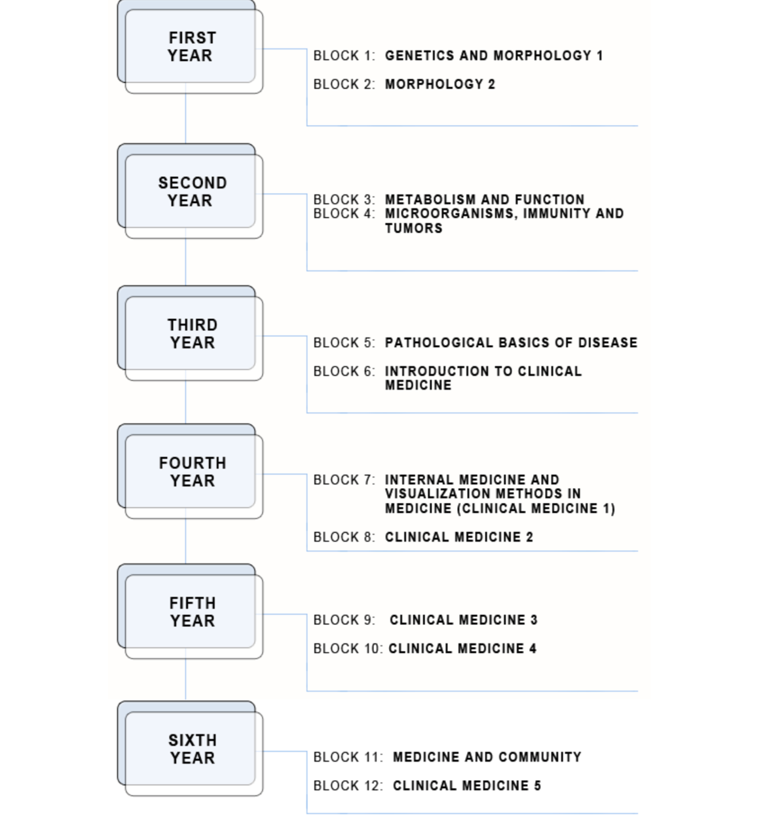

Course title:

HUMAN GENETICS

ECTS Credits: 6. Number of active classes per week: 4 (lectures: 2; practical classes: 2)

Teachers:

 | Name and surname | Email | title
1. | Biljana Ljujic | bljujic74@gmail.com | Full Professor
2. | Olivera Milosevic-Djordjevic | olivera@kg.ac.rs | Full Professor
3. | Danijela Todorovic | dtodorovic@medf.kg.ac.rs | Full Professor
4. | Marina Gazdic Jankovic | marinagazdic87@gmail.com | Associate Professor
5. | Dragana Papic | drmiloradovic7@gmail.com | Teaching Assistant
6. | Dragica Pavlovic | dragica.miloradovic8@gmail.c | Teaching Assistant
7. | Nikolina Kastratovic | n_kastratovic@outlook.com | Teaching Assistant

Course structure:

Module | Module title | Week | Theoretical classes per week | Practical classes per week | Teacher in charge:
1 | Organization of the human genome | 5 | 2 | 2 | Assoc. prof. Marina Gazdić Janković
2 | Significance of gene mutation and genetic determination of human traits | 6 | 2 | 2 | Full prof. Biljana Ljujić
3 | Developmental genetics and population genetics | 4 | 2 | 2 | Assoc. prof. Marina Gazdić Janković
Σ 30+30=60

Examination Methods:
By fulfilling the pre-exam obligations and taking the written/test exam, the student can achieve a maximum of 100 points.
The grade is equivalent to the number of points earned (see tables). Points are earned in two ways:

ACTIVITY DURING THE CLASSES:
In this way, the student earns up to 30 points, by answering 2 questions from that week's classes at the practical classes and, in accordance with the demonstrated knowledge, gaining from 0 - 2 points.

FINAL EXAM:
The student takes the final test during the exam period. The test includes 35 questions. Each question is worth 2 points. In this way, the student can acquire 70 points, according to the attached grading scheme.

Determination of final grade:

To pass the exam, the student must earn the minimum of 51 total points and to fulfill the following:
1. to earn more than 50% points on activity during classes
2. to earn more than 50% points on the final exam, which includes total teaching material.

Grading system

Final grade | Total number of points  Points grade | Description
10 | 91 – 100 | Excellent
9 | 81 – 90 | Exceptionally good
8 | 71 – 80 | Very good
7 | 61 – 70 | Good
6 | 51 – 60 | Passing
5 | < 51 | Falling

LITERATURE:

textbook | authors | publisher | library | reading room
Emery’s elements of medical genetics | Peter D. Turnpenny and Sian Ellard | Elsevier. 15th edition. 2017. | yes | yes

STUDY PROGRAM

THE MODULE 1: ORGANISATION OF HUMAN GENOME

Course unit 1 (1STWEEK):
EUKARYOTIC CHROMOSOMES

lecture 1 class | practice 1 class
Chemical composition of eukaryotic chromosome.  DNA packaging  Morphological features of chromosomes | Chemical composition of eukaryotic chromosome  DNA packaging  Morphological features of chromosomes  Human karyotype  Standardisation in human cytogenetics
lecture 1 class | practice 1 class
Human karyotype  Standardisation in human cytogenetics | Student activity assessment

Course unit 2 (2ndWEEK):
NUCLEAR AND MITOCHONDRIAL GENOMES

lecture 1 class | practice 1 class
The human nuclear genome: structure and organisation  Eukaryotic gene structure  Number and length of human nuclear genes  Gene polymorphism | Human nuclear and mitochondrial genome  Eukaryotic gene structure  Number and length of human nuclear genes  Gene polymorphism

lecture 1 class | practice 1 class
The mitochondrial genome: structure and organisation  Genes on the mitochondrial DNA  Maternal inheritance | Student activity assessment

Course unit 3 (3st WEEK):
GENETIC RECOMBINATION

lecture 1 class | practice 1 class
Genetic recombination. Recombination in viruses.  Conjugation, transformation and transduction  Genetic recombination in bacteria | Genetic linkage  The mechanism of crossing-over  Gene mapping- practice problems
lecture 1 class | practice 1 class
Genetic recombination in eukaryotes - crossing-over-mechanism, modification of crossing over frequency  Crossing over and genetic mapping  Interference and coincidence | Student activity assessment

Course unit 4 (4th WEEK):
GENETIC ENGINEERING - RECOMBINANT DNA TECHNOLOGY

lecture 1 class | practice 1 class
Clone and cloning  Gene cloning -methods of recombinant DNA technology | Gene cloning - methods of recombinant DNA technology. Reproductive cloning. Therapeutic cloning. Recombinant DNA in medicine
lecture 1 class | practice 1 class
Reproductive cloning  Therapeutic cloning  Recombinant DNA in medicine | Student activity assessment

Course unit 5 (5th WEEK):
EPIGENETICS. STEM CELLS AND THEIR APPLICATIONS. BLJ

lecture 1 class | practice 1 class
Introduction to epigenetics  Biology of stem cells  Types of stem cells  Molecular mechanisms of pluripotency and reprogramming | Introduction to epigenetics  Biology of stem cells  Types of stem cells  Molecular mechanisms of pluripotency and reprogramming  Stem cells applications in regenerative medicine
lecture 1 class | practice 1 class
Stem cells applications in regenerative medicine | Student activity assessment

THE MODULE 2: THE SIGNIFICANCE OF GENE MUTATION AND GENETIC DETERMINATION OF HUMAN TRAITS

Course unit 6 (6th WEEK):
NUMERICAL CHROMOSOME ABERRATIONS
lecture 1 class | practice 1 class
Definition and mechanism of polyploidy | Polyploidy andaneuploidy  Practice problems
lecture 1class | practice 1 class
Definition and mechanism of aneuploidy  Types of aneuploidy  Mixoploidy and chimerism | Student activity assessment

Course unit 7 (7th WEEK):

STRUCTURAL CHROMOSOME ABERRATIONS
lecture 1 class | practice 1 class
Types and mechanism of chromosomal deletion  Mechanism of chromosomal duplications  Isochromosome and dicentric chromosome  Types and mechanism of chromosomal inversion | Structural chromosome aberrations -deletion, duplications, inversion and translocations.  Practice problems
lecture 1 class | practice 1 class
Types and mechanism of chromosomal translocations  Differences between reciprocal translocations, Robertsonian translocations and insertions | Student activity assessment

Course unit 8 (8thWEEK):
CLINICAL FINDINGS IN CHROMOSOME ABERRATIONS
lecture 1 class |  | practice 1 class
Sex chromosome aneuploidies: Turner syndrome, Klinefelter syndrome, Triple X syndrome and XYY syndrome  Autosomal aneuploidies: Down's, Edwards' and Patau's syndromes |  | Clinical findings in chromosome aberrations.
lecture 1 class |  | practice 1 class
Chromosome deletion: Cri-Du-Chat syndrome, Wolf-Hirschhorn syndrome, malignant diseases.  Turner syndrome caused by X chromosome deletion  Syndromes caused by chromosomal translocations  Chromosomal aberrations-the cause of spontaneous abortions |  | Student activity assessment

Course unit 9 (9thWEEK):
GENE MUTATIONS
lecture 1 class | practice 1 class
Gene mutation: definition and types (somatic and germline mutations, spontaneous and induced mutations, micro and macro mutations)  Point mutation – substitution (missense, nonsense, silent and neutral mutations), frameshift mutations (insertions and deletions)  Dynamic mutation  Spontaneous mutation rates | Mechanisms of gene mutation
lecture 1 class | practice 1 class
DNA repair  DNA repair-deficiency disorder  Mutagens | Student activity assessment

Course unit 10 (10thWEEK):
PATTERNS OF INHERITANCE
lecture 1 class | practice 1 class
Dominance and recessiveness Autosomal-dominant inheritance Autosomal recessive inheritance  X-linked inheritance, Y-linked inheritance | Monohybrid inheritance  Dihybrid inheritance  Polygenic inheritance  Practice problems- making and analysis of genealogical trees
lecture 1 class | practice 1 class
Sex limited inheritance  Polygenic and multifactorial inheritance  Genetic linkage  Maternal inheritance | Student activity assessment

Course unit 11 (11th week):

PRENATAL DIAGNOSTIC OF CHROMOSOMOPATHY AND GENOPATHY

lecture 1class | practice 1 class
Prenatal diagnosis- indications  Methods for non-invasive and invasive prenatal diagnosis  Methods for invasive prenatal diagnosis:  amniocentesis, chorionic villus sampling, cordocentesis. Preimplantation genetic diagnosis | Prenatal diagnosis of chromosomopathies and genopathy  Methods in molecular genetics: hybridization, electrophoresis, blotting, PCR.
lecture 1class | practice 1 class
Prenatal diagnosis of genopathy  Basic methods in molecular genetics: nucleic acid isolation, electrophoresis, PCR, hybridization tests | Student activity assesment

THE MODULE 3: DEVELOPMENTAL GENETICS AND POPULATION GENETICS

Course unit 12 (12th week):
SEX- DETERMINATIONAND DIFFERENTIATION

lecture 1class | practice 1 class
A Barr body- X- hromosom inactivation in females  Role of X and Y chromosome sex diferentiation  Autosomal chromosome genes responsible for gonad differentiation-SOX9, SF1, WT1 | X- hromosom inactivation. Mary Lyon hypothesis  Solving problem tasks.
lecture 1class | practice 1 class
Human sexual disorders. Sex reversions.  Hermaphroditism. | Student activity assesment

Course unit 13 (13th week):
THE GENETICS OF IMMUNITY
lecture 1class | practice 1 class
Antigen  Antibody structure and function  Immune response mechanism  Antibody genes  HLA system | Multiple allelism  Hierarchical relationship between alleles  Codominant relationship between alleles  Blood types  ABO blood group system МN blood group system  Rh blood group system  Solving problem tasks.
lecture 1class | practice 1 class
Immunogenetics of blood groups:  ABO blood group system  МN blood group system  Rh blood group system | Student activity assesment

Course unit 14 (14th week):
ONCOGENETICS. GENETICS OF AGING
lecture 1class | practice 1 class
Characteristics of the malignant cell  Types of cancers according to the type of cell from which they arise.  Carcinogens  Chromosomal aberrations in cancer  Viral origin of cancer | The genetic basis of cancer – chromosomal aberrations and gene mutations in malignancies.
Practice 1 class | practice 1 class
Genetic basis of cancer: protooncogene, oncogene, cancer-suppressor gene  p53 gene Aging | Student activity assesment

Course unit 15 (15th week):
POPULATION GENETICS

lecture 1class | practice 1 class
Definition and characteristics of human populations.  Genetic structure of a population- The Hardy-Weinberg equilibrium principle.  Panmixia. | Genetic structure of a population-The Hardy- Weinberg equilibrium principle.  Solving problem tasks.
lecture 1class | practice 1 class
Factors that disrupt the population's genetic structure: natural selection, mutations, migrations, genetic coincidence  Genetic load- consanguineous marriages. | Student activity assesment

Schedule of teaching lectures

Schedule of practical classes

SCHEDULE
module | week | date | time | place | type | title of the lecture | teacher
1 | 1 |  |  |  | L | Chromosomes of eukaryotes. Human karyotype. | Prof. dr Marina Gazdic Jankovic
1 | 1 |  |  |  | P | Chromosomes of eukaryotes. Human karyotype. | Dragica Pavlović  Nikolina Kastratović
1 | 2 |  |  |  | L | Nuclear and mitochondrial genome | Prof. dr Marina Gazdic Jankovic
1 | 2 |  |  |  | P | Nuclear and mitochondrial genome | Dragica Pavlović  Nikolina Kastratović
1 | 3 |  |  |  | L | Genetic recombination | Prof. dr Marina Gazdic Jankovic
1 | 3 |  |  |  | P | Genetic recombination | Dragica Pavlović  Nikolina Kastratović
1 | 4 |  |  |  | L | Genetic engineering - recombinant DNA technology | Prof. dr Marina Gazdic Jankovic
1 | 4 |  |  |  | P | Genetic engineering – recombinant DNA technology | Dragica Pavlović  Nikolina Kastratović
1 | 5 |  |  |  | L | Epigenetics. Stem cells and their applications. | Prof. dr Marina Gazdic Jankovic
1 | 5 |  |  |  | P | Epigenetics. Stem cells and their applications. | Dragica Pavlović  Nikolina Kastratović
2 | 6 |  |  |  | L | Numerical chromosome aberrations | Prof. dr Biljana Ljujic
2 | 6 |  |  |  | P | Numerical chromosome aberrations | Dragica Pavlović  Nikolina Kastratović

SCHEDULE
module | week | date | time | place | type | title of the lecture | teacher
2 | 7 |  |  |  | L | Structural chromosome aberrations | Prof. dr Marina Gazdic Jankovic
2 | 7 |  |  |  | P | Structural chromosome aberrations | Dragica Pavlović  Nikolina Kastratović
2 | 8 |  |  |  | L | Clinical findings in chromosome aberrations | Prof. dr Biljana Ljujic
2 | 8 |  |  |  | P | Clinical findings in chromosome aberrations | Dragana Papić  Dragica Pavlović  Nikolina Kastratović
2 | 9 |  |  |  | L | Gene mutations | Prof. dr Marina Gazdic Jankovic
2 | 9 |  |  |  | P | Gene mutations | Dragica Pavlović  Nikolina Kastratović
2 | 10 |  |  |  | L | Patterns of inheritance | Prof. dr Biljana Ljujic
2 | 10 |  |  |  | P | Patterns of inheritance | Dragica Pavlović  Nikolina Kastratović
2 | 11 |  |  |  | L | Prenatal diagnostic of chromosomopathy and genopathy | Prof. dr Biljana Ljujic
2 | 11 |  |  |  | P | Prenatal diagnostic of chromosomopathy and genopathy | Dragica Pavlović  Nikolina Kastratović

SHEDULE

module | week | date | time | place | type | title of the lecture | teacher
3 | 12 |  |  |  | L | Sex- determination and differentiation | Prof. dr Marina Gazdic Jankovic
3 | 12 |  |  |  | P | Sex- determination and differentiation. | Dragica Pavlović  Nikolina Kastratović
3 | 13 |  |  |  | L | The genetics of immunity | Prof. dr Biljana Ljujic
3 | 13 |  |  |  | P | The genetics of immunity | Dragica Pavlović  Nikolina Kastratović
3 | 14 |  |  |  | L | Oncogenetics | Prof. dr Marina Gazdic Jankovic
3 | 14 |  |  |  | P | Oncogenetics | Dragica Pavlović  Nikolina Kastratović
3 | 15 |  |  |  | L | Population genetics | Prof. dr Marina Gazdic Jankovic
3 | 15 |  |  |  | P | Population genetics | Dragica Pavlović  Nikolina Kastratović

